(Approx. 368 words)

Timeshift Rescue
By Cal Esneault, Past President and leader of many Open-Source Workshops & SIGs
Cajun Clickers Computer Club
https://www.clickers.org/
cpesne (at) bellsouth.net

Any software update involving a PC operating system (OS) has the possibility of causing serious issues. Therefore, Linux Mint added a default OS backup application called “Timeshift.” In 2019, Mint started assuming you were using this program so that it could release updates without previous complicated warning messages. After installing Mint 20.3, I set the weeklyTimeshift backup schedule with retention of only the latest three images to save disk space. A review of the Timeshift log at the time of an incident is shown below.

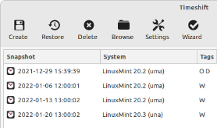

Trouble started when I went to the update manager to get the latest updates. I did not get the normal authentification dialog box, and the updates did not respond. I tried to change the repository mirror in case of an issue with the Mint end, but it would not give me the authentification dialog either. Also, clicking the Timeshift icon would not launch the backup program (same issue, not authentication access). Searching the internet, I tried suggestions to clear the apt-cache, but this did not resolve the problem.

Next, I went to the terminal and launched Timeshift via the command line. Below is a partial response. It listed the correct commands to check my backups and pick one to restore from (see below).

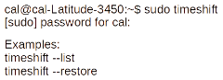

I proceeded with the restore (choosing the latest) about a week before the issue appeared (see below).

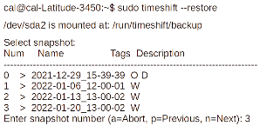

After rebooting, the system was restored, and I could update again without any issues. I guess that some GUI quirk had occurred. This was the first time I had to use Timeshift for a real problem. Although previously skeptical, I am now a true believer. This is a program every Linux Mint or Ubuntu user should activate.

Note that Timeshift enables the user to split the OS backup with installed applications separately from user files (for example, data stored in the /home directory; I routinely back up data files using a different method). The alternative to this dual approach is to make a “mirror” image of the entire disk. I find the dual approach a more straightforward and faster method.

